Marketing 101 Assignment

1. The file contains profiling (distributions) for 6 segments C2-T2. Variables have been listed in column A, variable buckets have been listed in column B. Below is an example for segment 1 with distribution for propensity to be a non-religious donor.

1. The data dictionaries for the variables can be accesses from Epsilon Data Dictionaries.zip situated in the same folder.
2. Your group will need to analyze the profiles and create personas for each of the segments. An example is below. The expectation is to get creative and provide a wholesome persona of the segment. You will also provide a strategy to target these segments.

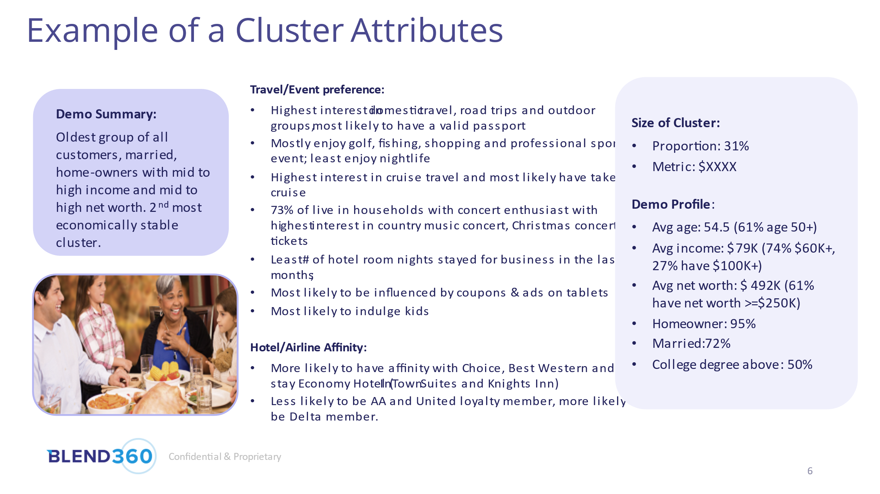

1. You will be evaluated on the content, clarity with which segments have been defined, presentation skills and creativity. The deliverable will be a PowerPoint deck from the group along with the workings. The presentation will be for 15 min.